**CS 570 Software Testing**

**HOP01A – Visual Studio Code (VSCode)**

1/10/2019 Developed by Sam Chung

School of Technology & Computing (STC)

City University of Seattle (CityU)

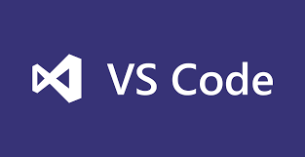

**Caution**

* If you already finished this module through any CityU Technology Institute (TI) courses,  
  just skim this module and skip it.
* Some version numbers may not match with the newly released ones.  
  If so, stay with the most recent ones.
* We target Windows OS. So, Mac may have different options.
* We cannot explain every steps. This cookbook always needs your own creative judgement.

**Learning Outcomes**

* Learn how to install Microsoft “Visual Studio Code (VSCode)

**Installing VSCode**

1. Visit <https://code.visualstudio.com/>

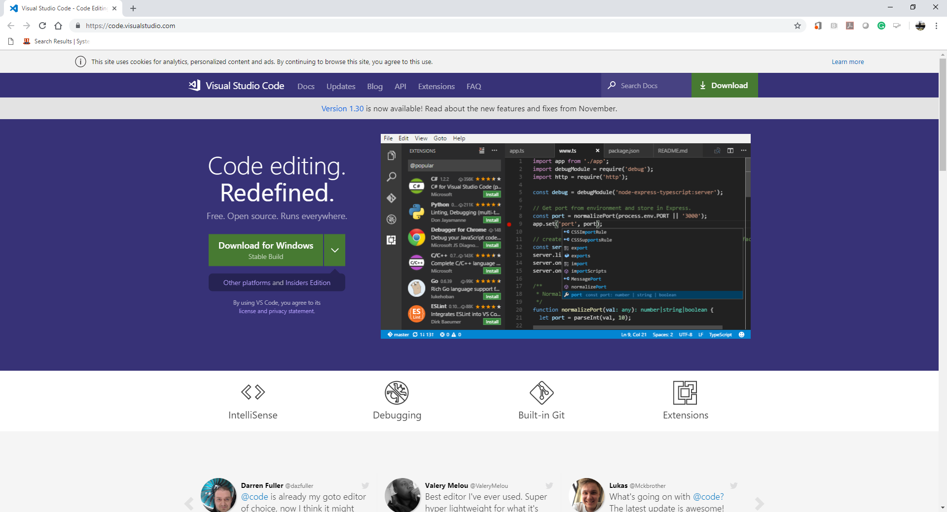

1. Select a correct version for your operating system and download it.  
   For example, you can download “VSCodeUserSetup-x64-1.30.2” for your Windows 10.  
   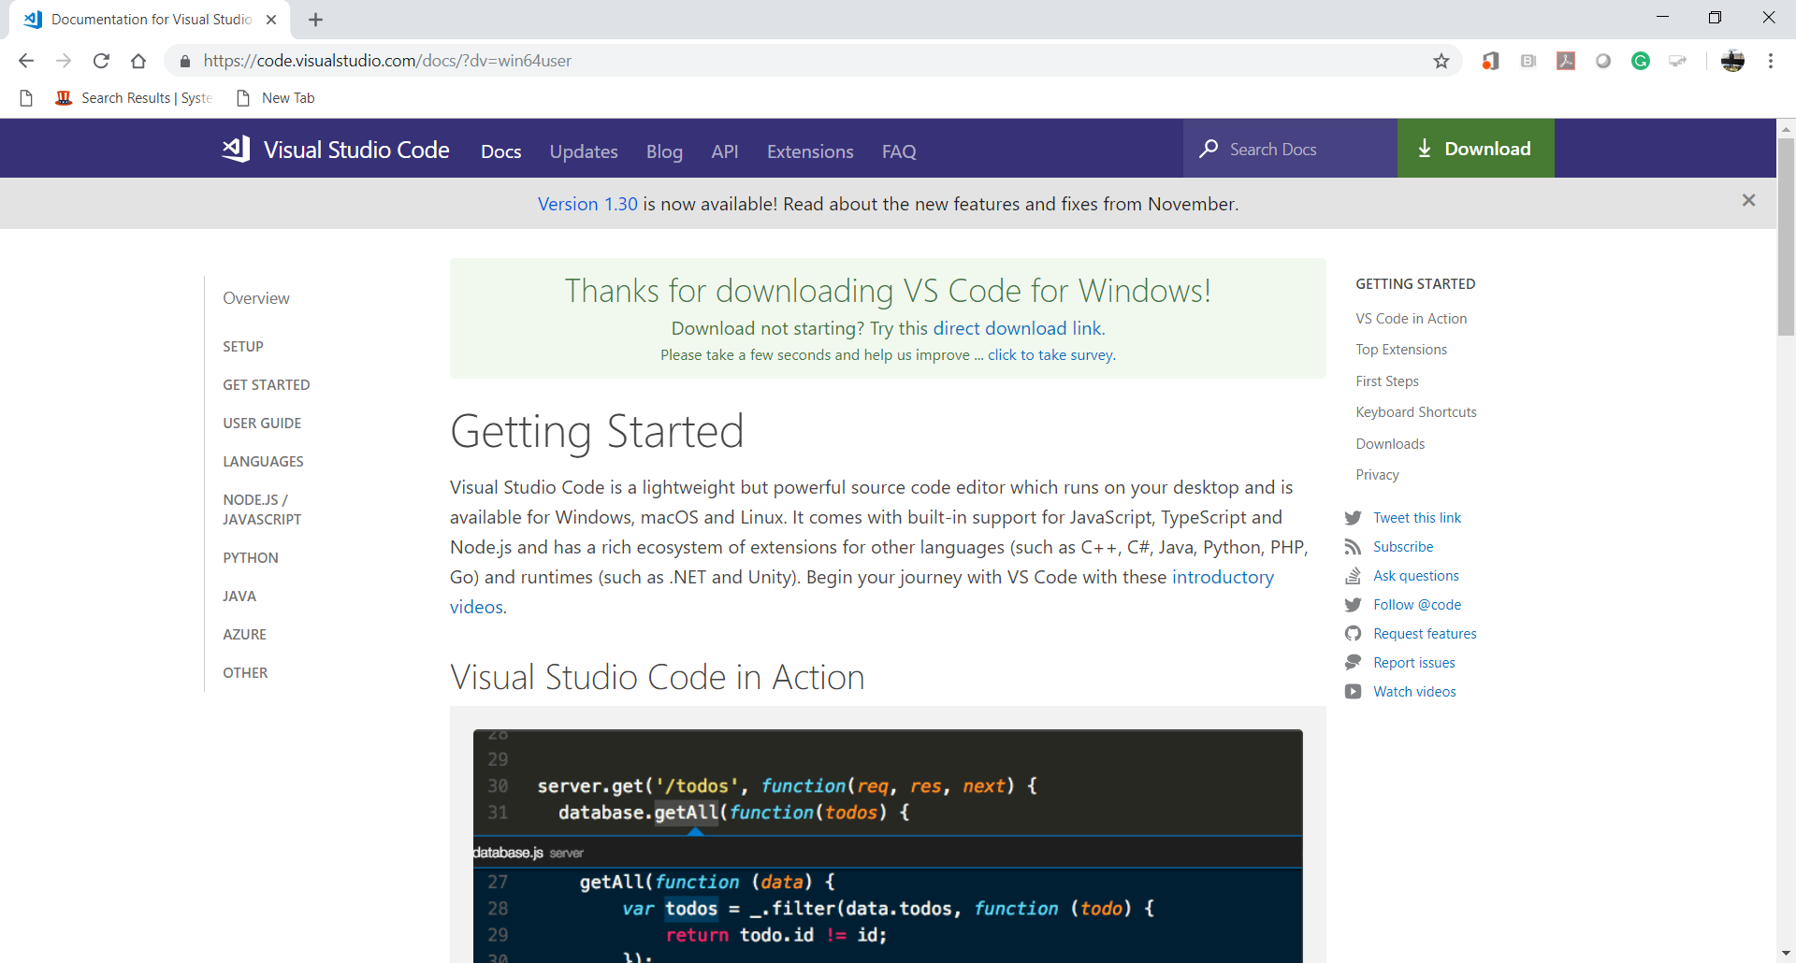
2. Install VSCode.  
   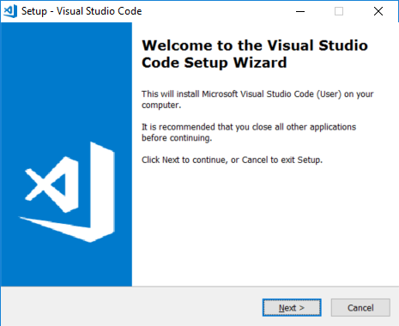

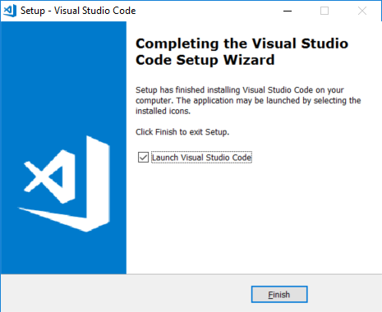  
  
  
  
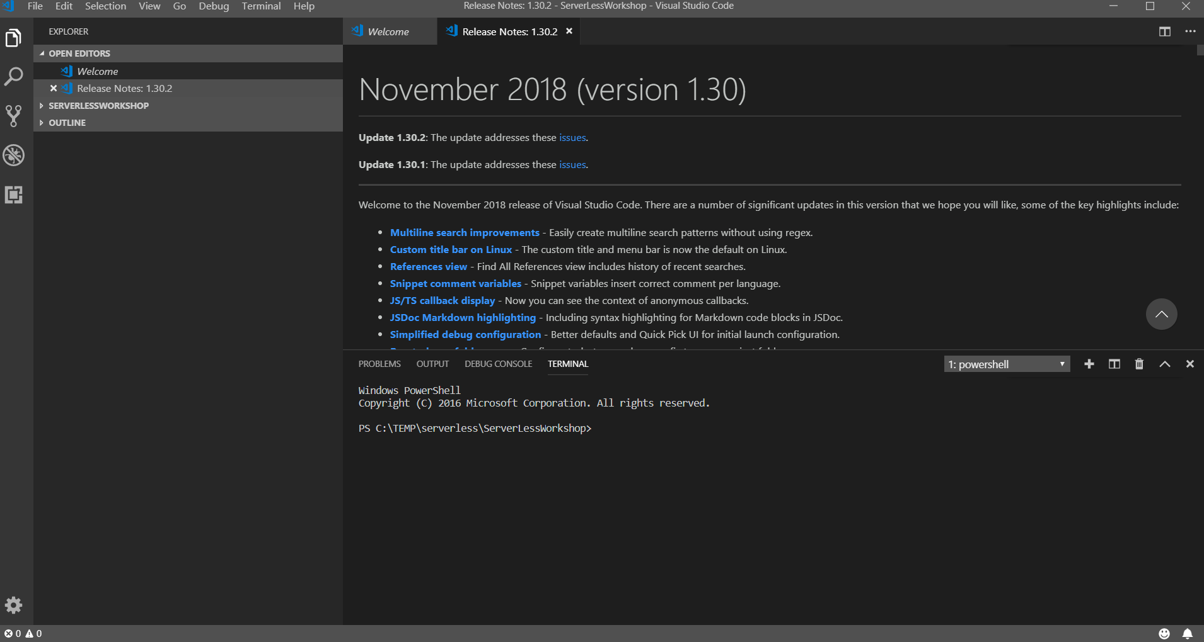

1. After installing the VSCode, close the opened VSCode.  
   Go to “File” menu end select ‘Exit” menu item.
2. Open the VSCode again.
3. Go to “View” menu and select “Terminal” menu item for your Command Line Interface (CLI)  
   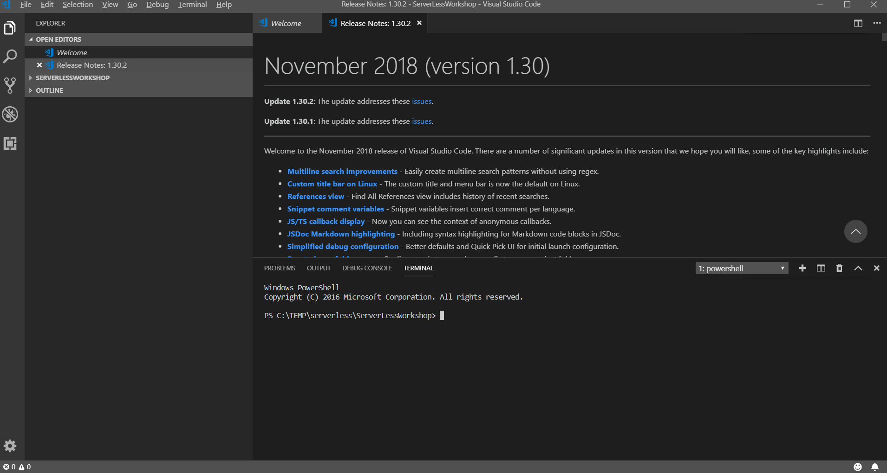
4. Go to the root directory of your disk drive.  
   Create a working directory called “cs570” for your course and move to the directory.  
   The following commands under Windows will be used.  
   >> cd /  
   >> mkdir cs570  
   >> cd cs570  
   >> dir  
    For more information about Windows commands, please visit <https://www.thomas-krenn.com/en/wiki/Cmd_commands_under_Windows>   
     
   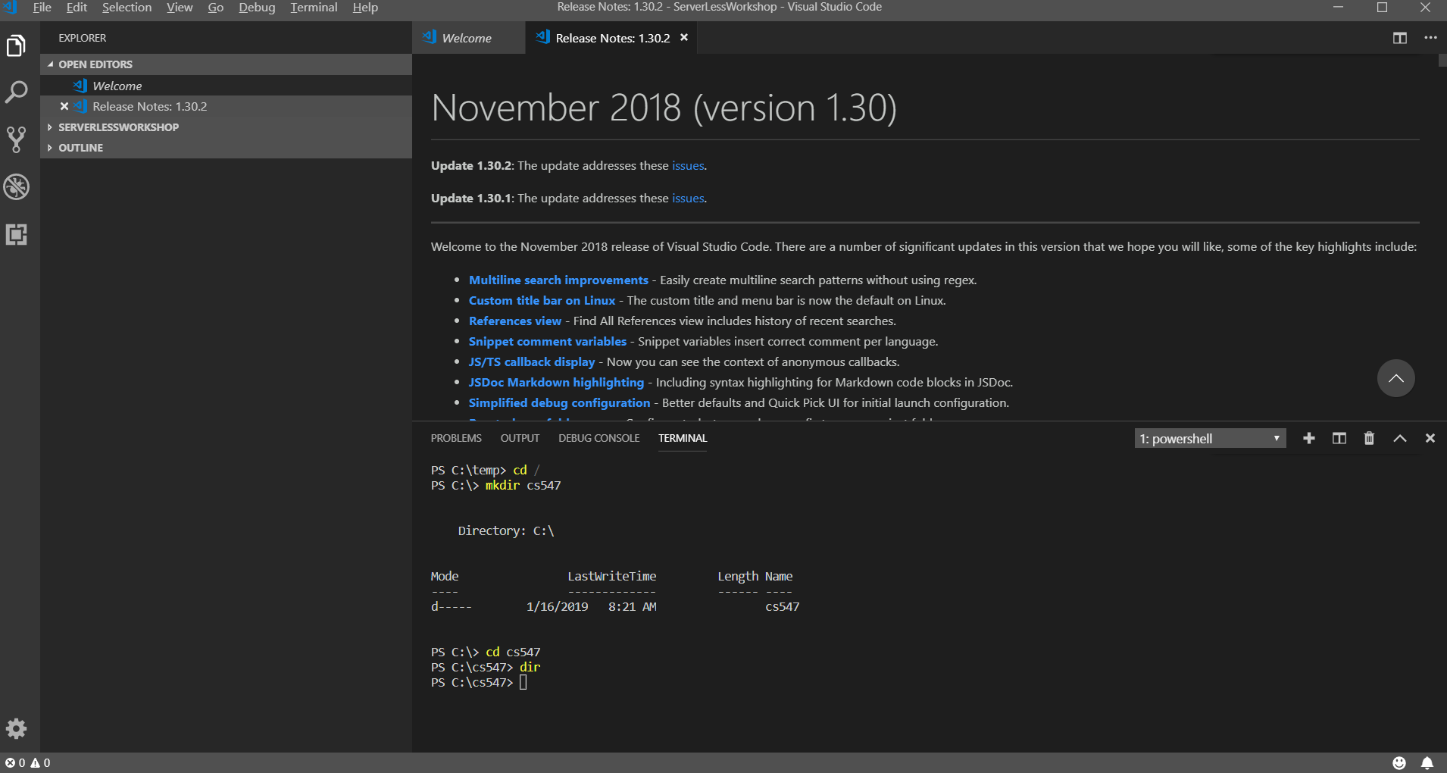
5. Clear your CLI.  
   >> cls
6. Close the VSCode.

Questions:

1. What is Visual Studio Code?  
   Show a good reference(s) to support your answer.  
   (Answer)
2. Why do you use the Visual Studio Code instead of Visual Studio (Community edition)?  
   Show a good reference(s) to support your answer.  
   (Answer)